EXPERIMENT - 5
Prioritizing Requirements Using the MoSCoW Method (Library Management System)

Field | Details
Name | M.Ramprasadh
Register No. | 192511355
Course Code | CSA1007
Date | 14 October 2026
Tool Used | Microsoft Excel

1. Aim
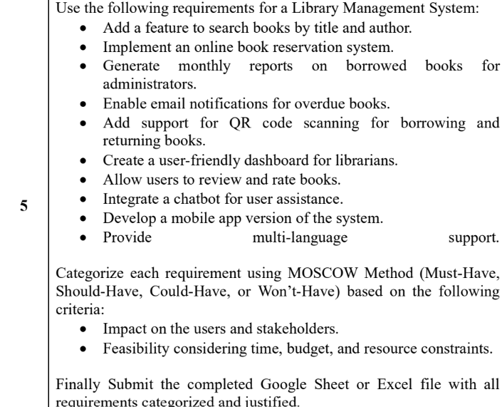

2. Objectives
- List the requirements of the Library Management System.
- Assess the impact of each requirement on users and stakeholders.
- Assess the feasibility of each requirement (time, budget and resources).
- Classify every requirement as Must-Have, Should-Have, Could-Have or Won't-Have.
- Write a clear justification for each priority decision.

3. Basic Concepts (in Simple Words)
MoSCoW: A method to decide which features to build first. The name comes from the four categories: Must, Should, Could and Won't.
Must-Have: Essential for the basic working of the system. Without it the first release is not successful.
Should-Have: Important and valuable, but the system can work without it for some time.
Could-Have: Nice to have. Added only if time and resources allow.
Won't-Have (for now): Not included in the current release. It may be reconsidered later.
Impact: How much a requirement helps users (students, readers) and stakeholders (librarians, administrators).
Feasibility: How easy it is to build the requirement with the available time, budget and resources.

4. Requirements
- A computer with Microsoft Excel (or any spreadsheet software such as Google Sheets).
- The list of 10 requirements of the Library Management System.
- Assumption: a student project with limited time, budget and development resources.

5. Step-by-Step Procedure
Part A: Prepare the Requirement List
- Open Excel. Open Microsoft Excel and create a new blank workbook.
- Rename the sheet. Rename the first sheet as 'MoSCoW Prioritization'.
- Create the column headings. In row 1 type: S. No., Requirement, Priority (MoSCoW), Impact on Users & Stakeholders, Feasibility (Time, Budget & Resources) and Justification.
- Enter the requirements. Type the 10 requirements of the Library Management System (searching books, online reservation, monthly reports, email notifications, QR scanning, librarian dashboard, reviews and ratings, chatbot, mobile app, multi-language support) in the Requirement column and number them 1 to 10.
Part B: Assess Impact and Feasibility
- Judge the impact. For each requirement, write in the Impact column how strongly it helps readers, librarians and administrators (High, Medium to High, Medium, and so on) with a short reason.
- Judge the feasibility. In the Feasibility column, write how easily the requirement can be built within the limited time, budget and resources (High, Medium, Low) with a short reason.
Part C: Assign the MoSCoW Category
- Understand the categories. Create a second sheet named 'MoSCoW Guide' with the meaning of Must-Have, Should-Have, Could-Have and Won't-Have and how each is used in this experiment.
- Apply the rules. Give Must-Have to requirements with high impact that are also feasible and essential for basic operation. Give Should-Have to valuable ones that have a temporary workaround. Give Could-Have to convenient extras. Give Won't-Have to requirements that are too costly for the first release.
- Fill the Priority column. Enter the chosen category for each requirement in the Priority (MoSCoW) column.
- Write the justification. In the Justification column, explain in one sentence why that category was chosen.
Part D: Format and Review
- Format the sheet. Make the header row bold, wrap the text, adjust the column widths and colour the Priority cells (for example green for Must-Have, yellow for Should-Have, blue for Could-Have and red for Won't-Have).
- Count the categories. Count how many requirements fall under each category and check that the Must-Have items are enough to run a basic library system.
- Save and capture the output. Save the file as 'Exp5_MoSCoW_Library_Management.xlsx' and take a screenshot of the sheet (shown in Section 8).

6. Requirements and Their MoSCoW Priority
No. | Requirement | Priority | Release
1 | Search books by title and author | Must-Have | Initial release
2 | Implement an online book reservation system | Should-Have | Next release
3 | Generate monthly reports on borrowed books for administrators | Should-Have | Next release
4 | Enable email notifications for overdue books | Should-Have | Next release
5 | Add QR code scanning for borrowing and returning books | Could-Have | Later phase if resources permit
6 | Create a user-friendly dashboard for librarians | Must-Have | Initial release
7 | Allow users to review and rate books | Could-Have | Later phase if resources permit
8 | Integrate a chatbot for user assistance | Could-Have | Later phase if resources permit
9 | Develop a mobile app version of the system | Won't-Have (this release) | Excluded from this release
10 | Provide multi-language support | Could-Have | Later phase if resources permit

7. Detailed Prioritization (Impact, Feasibility and Justification)
No. | Requirement | Category | Impact on Users / Stakeholders | Feasibility (Time, Budget, Resources) | Justification / Rationale
1 | Search books by title and author | Must-Have | Very high: users need a reliable way to find items in the library catalogue. | High feasibility: basic catalogue search is a standard feature and needs limited extra infrastructure if book records already exist. | Core discovery function. Without search, users and librarians cannot efficiently locate books, so it belongs in the first release.
2 | Implement an online book reservation system | Should-Have | High: users can reserve unavailable or popular books without visiting the library in person. | Medium feasibility: requires reservation rules, availability checks, queue handling, and user/account integration. | Strong user value, but the basic catalogue and circulation workflow can launch first; reservation can follow if time is limited.
3 | Generate monthly reports on borrowed books for administrators | Should-Have | High for administrators: supports monitoring borrowing activity and planning collection or staffing needs. | Medium-to-high feasibility: reports can be generated from borrowing transaction data, but report formats and filters need implementation. | Important administrative feature, though a first release can operate with simpler transaction views before scheduled monthly reports are added.
4 | Enable email notifications for overdue books | Should-Have | High: helps borrowers return books on time and helps librarians reduce overdue items. | Medium feasibility: needs a mail service, valid user email addresses, reminder rules, and failure handling. | Valuable automation, but circulation can initially be managed manually while email delivery and reminder scheduling are configured.
5 | Add QR code scanning for borrowing and returning books | Could-Have | Medium-to-high: can speed up counter transactions and reduce manual entry errors. | Medium feasibility: needs QR labels, camera/scanner support, and integration with the borrowing/return workflow. | A useful efficiency upgrade, but manual ID/barcode entry can support borrowing and returns in the first release.
6 | Create a user-friendly dashboard for librarians | Must-Have | Very high: librarians need a clear place to manage books, borrowers, loans, returns, and overdue items. | High feasibility: a basic dashboard can be built using existing system data and standard web interface components. | Essential for day-to-day staff operations and usability; without it, core library tasks would be difficult to manage.
7 | Allow users to review and rate books | Could-Have | Medium: reviews can help readers choose books and encourage engagement. | Medium feasibility: requires rating/review storage, display, and potentially moderation or abuse controls. | An engagement feature rather than a core circulation need. Defer until the main catalogue and borrowing workflows are stable.
8 | Integrate a chatbot for user assistance | Could-Have | Medium: can answer common questions and reduce repetitive enquiries to library staff. | Low-to-medium feasibility: useful responses require a maintained knowledge base or AI service, testing, and potentially recurring costs. | Potentially useful, but standard help/FAQ content is a simpler and more affordable first-release alternative.
9 | Develop a mobile app version of the system | Won't-Have (this release) | Medium-to-high: mobile access is convenient, but users can still access core functions through a responsive website. | Low-to-medium feasibility under a constrained release: a separate app adds development, device testing, publishing, and maintenance effort. | Excluded from the current release to protect time and budget. Reassess after the web system is stable and user demand is measured.
10 | Provide multi-language support | Could-Have | Medium-to-high in a multilingual user community: it improves accessibility for users who prefer different languages. | Medium feasibility: needs translated interface text, language selection, and ongoing review of translations. | Desirable for inclusion, but a single-language first release is feasible; add languages based on user needs and available translation resources.

8. Output (Screenshot of the Sheet)

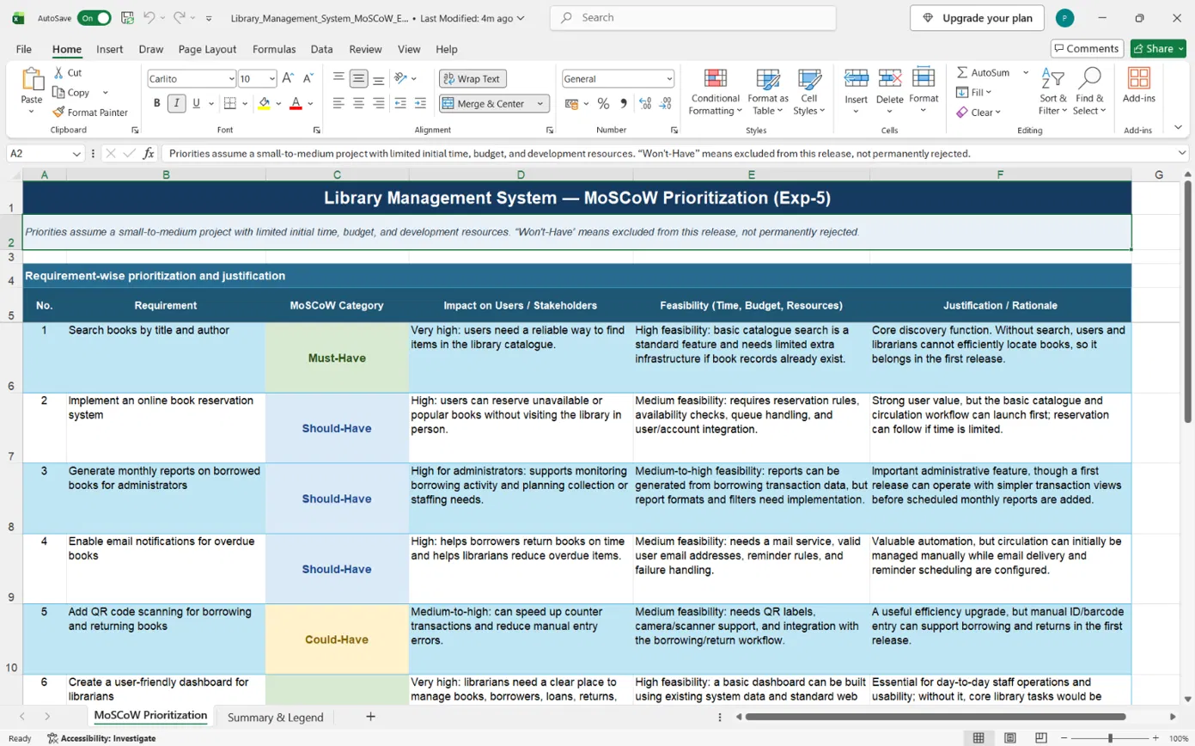
Figure 1: MoSCoW prioritization of the Library Management System requirements
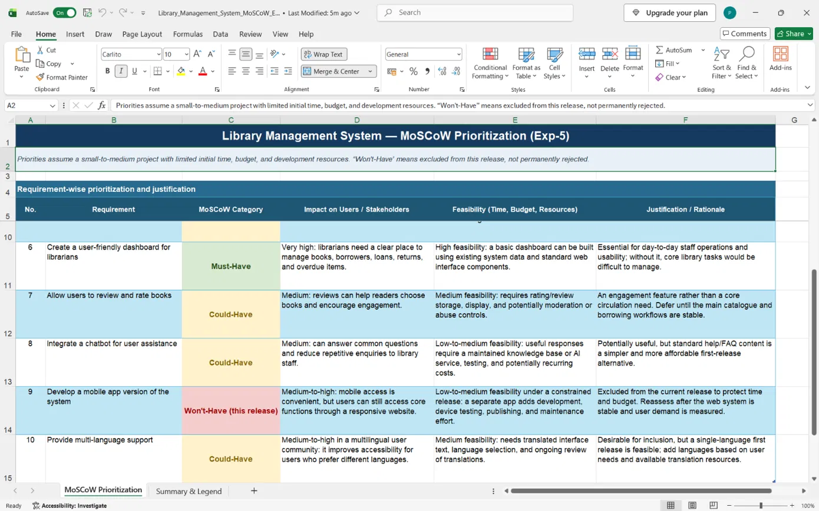
Figure 2: MoSCoW prioritization of the Library Management System requirements

9. Observation
Category | Count | Requirements
Must-Have | 3 | Search books by title and author; Online book reservation system; User-friendly dashboard for librarians
Should-Have | 2 | Monthly reports on borrowed books; Email notifications for overdue books
Could-Have | 4 | QR code scanning; Review and rate books; Chatbot for user assistance; Multi-language support
Won't-Have (initial release) | 1 | Mobile app version of the system
Total | 10

The Must-Have items cover the core library workflow of finding books, reserving them and managing them through a librarian dashboard. Items that need extra setup, cost or testing (QR scanning, chatbot, mobile app) were moved to lower priority.

10. Result
The 10 requirements of the Library Management System were prioritized using the MoSCoW method. 3 were classified as Must-Have, 2 as Should-Have, 4 as Could-Have and 1 as Won't-Have for the initial release, each with an impact assessment, feasibility assessment and justification.

11. Conclusion
This experiment showed that the MoSCoW method helps a team decide what to build first when time, budget and resources are limited. Weighing the impact on users against the feasibility of each requirement gives a clear and fair priority order. Delivering the Must-Have features first ensures a working system early, while the other features can be added in later releases.

